Spring Framework

* What is spring
* When we should use it
* Why is it so popular
* What type of applications?

Open Source, Lightweight, DI Container, Framework 🡪 building java enterprise applications

<https://github.com/spring-projects/spring-framework>

<http://mvnrepository.com/artifact/org.springframework>

<http://docs.spring.io/spring/docs/current/spring-framework-reference/htmlsingle>

maven use is recommended

lightweight – don’t need a runtime - don’t need an application server

not invasive – do not require you to extend framework classes or implement framework interfaces

low overhead – spring jars are relatively small

DI Container

* Servers as a lifecycle manager and instantiates and injects dependencies into your objects
* DI Container is sometimes called IOC Container
* Enterprise applications must deal with a wide variety of tech

Containerization

Cloud

JDBC, ORM

Streaming, events , JMS

Security

Monitoring

Provides classes to simplify working with lower-level techs

Extensible and customizable.

DI Container – heart of spring

* Don’t repeat yourself
* Separation of concerns
* Convention over configuration
* Testability

A typical application consists of several parts working together to carry out a use case

Eg. Service and Repository.

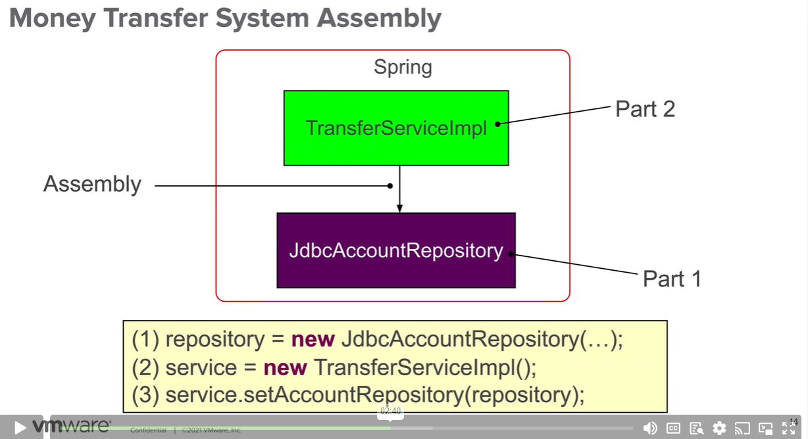

Above is the equivalent code

Notice that service depends on an interface and not an implementation.

For testing, when there is no container, you can create your own stub – so this simplifies testing a lot

Spring framework history

* 2003 – first release
* J2EE difficult to use and test
* Spring – dependency injection, jdbc data access, support for multiple envs
* Code quality
* OSS community
* Careful API design
* Adaptable to change – integration with other open source projects like hibernate
* Spring projects – sprint secutityy
* Spring boot
* 2003 – 0.9 version
* Spring - integration with web apps, messaging, persistence, batch, streaming
* Spring adaptability - jdk, nativa compilation, reactive , Kotlin, Kubernetes
* First lab.

Lab

We need to run mvn clean install – so that it will be available as a library to be used.



We open the following project

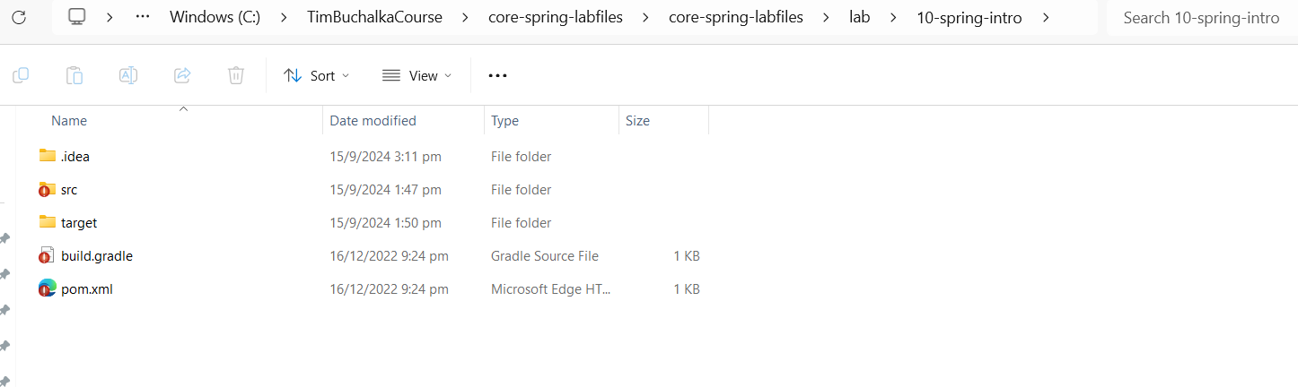

This project is dependent upon the following

00-rewards-common

Where is the 00-rewards-common jar coming from ?

Lets look at the m2 repository

Its coming from there!

So we have to mvn clean build this project first

Lets do a mvn clean and try

Deleted the library

Now the project got errors

build the commons module

Npw check the m2 again

Errors in proj should have disappeared

Now we will test this method

This method belongs to the class

RewardNetworkImpl

To test this method, we need a @Test Annotation

As per the below code

package rewards.internal;  
  
import common.money.MonetaryAmount;  
import org.junit.jupiter.api.BeforeEach;  
import org.junit.jupiter.api.Disabled;  
import org.junit.jupiter.api.Test;  
import rewards.AccountContribution;  
import rewards.Dining;  
import rewards.RewardConfirmation;  
import rewards.internal.account.AccountRepository;  
import rewards.internal.restaurant.RestaurantRepository;  
import rewards.internal.reward.RewardRepository;  
  
import static org.junit.jupiter.api.Assertions.*assertEquals*;  
import static org.junit.jupiter.api.Assertions.*assertNotNull*;  
  
*/\*\*  
 \* Unit tests for the RewardNetworkImpl application logic.  
 \* Configures the implementation with stub repositories  
 \* containing dummy data for fast in-memory testing without  
 \* the overhead of an external data source.  
 \*   
 \* Besides helping catch bugs early, tests are a great way  
 \* for a new developer to learn an API as he or she can see the  
 \* API in action. Tests also help validate a design as they  
 \* are a measure for how easy it is to use your code.  
 \*/*public class RewardNetworkImplTests {  
  
 */\*\*  
 \* The object being tested.  
 \*/* private RewardNetworkImpl rewardNetwork;  
  
 // *TODO-09: Review the test setup* @BeforeEach  
 public void setUp() throws Exception {  
 // Create stubs to facilitate fast in-memory testing with  
 // dummy data and no external dependencies  
 AccountRepository accountRepo = new StubAccountRepository();  
 RestaurantRepository restaurantRepo = new StubRestaurantRepository();  
 RewardRepository rewardRepo = new StubRewardRepository();  
  
 // Setup the object being tested by handing what it needs to work  
 rewardNetwork = new RewardNetworkImpl(accountRepo, restaurantRepo, rewardRepo);  
 }  
  
 // *TODO-10: Test RewardNetworkImpl class* // - Remove the @Disabled annotation below.  
 // - Run this JUnit test. Verify it passes.  
 @Test  
 //@Disabled  
 public void testRewardForDining() {  
 // create a new dining of 100.00 charged to credit card '1234123412341234' by merchant '123457890' as test input  
 Dining dining = Dining.*createDining*("1500.00", "1234123412341234", "1234567890");  
  
 // call the 'rewardNetwork' to test its rewardAccountFor(Dining) method  
 RewardConfirmation confirmation = rewardNetwork.rewardAccountFor(dining);  
  
 // assert the expected reward confirmation results  
 *assertNotNull*(confirmation);  
 *assertNotNull*(confirmation.getConfirmationNumber());  
  
 // assert an account contribution was made  
 AccountContribution contribution = confirmation.getAccountContribution();  
 *assertNotNull*(contribution);  
  
 // the account number should be '123456789'  
 *assertEquals*("123456789", contribution.getAccountNumber());  
  
 // the total contribution amount should be 8.00 (8% of 100.00)  
 *assertEquals*(MonetaryAmount.*valueOf*("300.00"), contribution.getAmount());  
  
 // the total contribution amount should have been split into 2 distributions  
 *assertEquals*(2, contribution.getDistributions().size());  
  
 // each distribution should be 4.00 (as both have a 50% allocation)  
 *assertEquals*(MonetaryAmount.*valueOf*("120.00"), contribution.getDistribution("Annabelle").getAmount());  
 *assertEquals*(MonetaryAmount.*valueOf*("180.00"), contribution.getDistribution("Corgan").getAmount());  
 }  
}

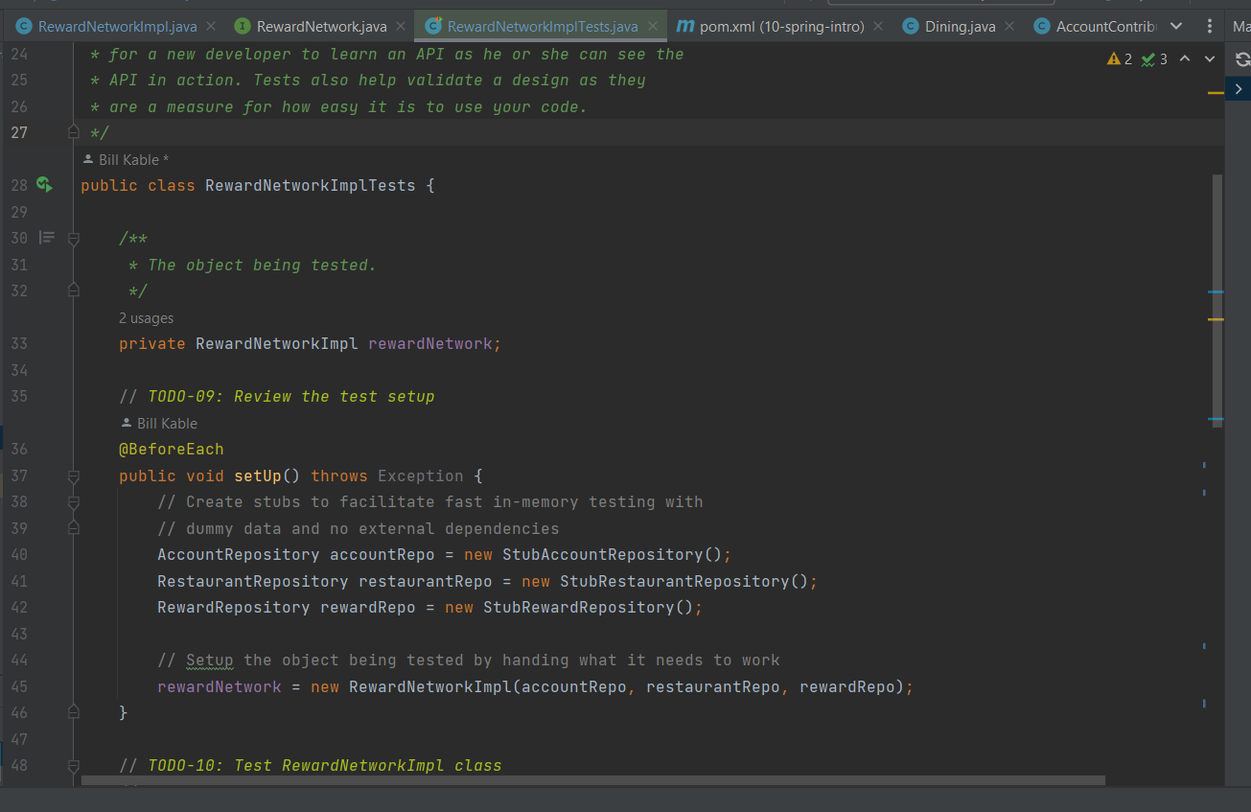

Notice that the rewardNetworkImpl object’s dependencies, could easily be stubbed because of the loose coupling!

The setup method has a BeforeEach annotation, which means it will run before the execution of each test

